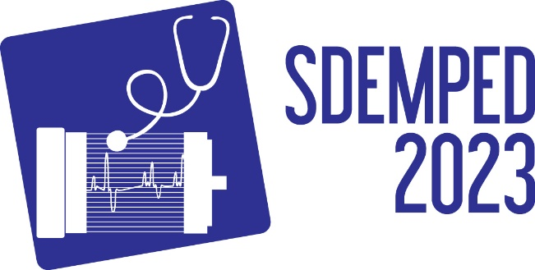
IEEE SDEMPED 2023
14th Edition of the IEEE International Symposium on Diagnostics for Electric Machines,
Power Electronics and Drives
28-31 August 2023 Chania, Greece

Special Session on:
“Title of the proposed special session”

Organisers
Title and full name, affiliation, country
email
&
Title and full name, affiliation, country
email

Technical Outline and Topics:
Short description of the special session area and scope. The outline and topics should not exceed 1 page together with the conference info, title and organizers. Topics of interest include but are not limited as below:
- Topic 1
- Topic 2
- etc…

