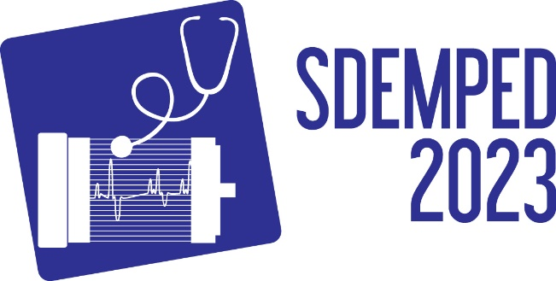
IEEE SDEMPED 2023
14th Edition of the IEEE International Symposium on Diagnostics for Electric Machines,
Power Electronics and Drives
28-31 August 2023 Chania, Greece

Tutorial on:
“Title of the proposed tutorial”

Organisers
Title and full name, affiliation, country
email
&
Title and full name, affiliation, country
email

Tutorial Scope and Learning Outcomes:
Short description of the tutorial area and scope. The scope and outcomes should not exceed 1 page together with the conference info, title and organizers. This tutorial’s learning outcomes are as follows:
- Learning outcome 1
- Learning outcome 2
- etc…

